MICHIGAN
PRELIMINARY BREATH TESTING
TRAINING MANUAL 2018

CLASS I OPERATOR

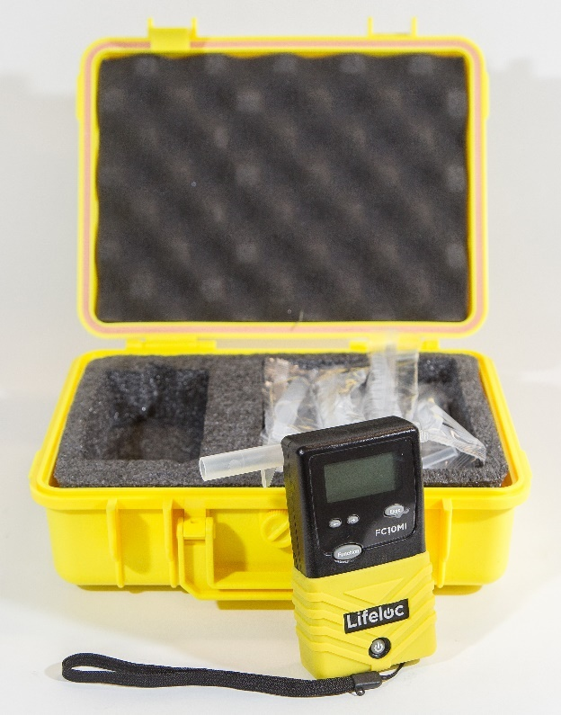

MICHIGAN STATE POLICE
TRAINING DIVISION

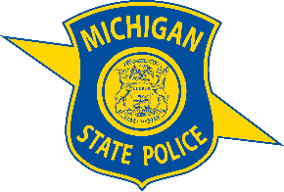
Table of Contents
Preface 3
Introduction 4
FC10 - Functional Parts 5
FC10 Interior Components 5
FC10 Exterior Components 6
FC10 – Subject Test Sequence 8
Observation: 8
Preparation: 8
Automatic Operation 9
Manual Operation 9
Passive Operation 10
FC10 Error Messages 11
Additional PBT Operational Tips 12
Administrative Rules 13
R 325.2651 Definitions. 13
R 325.2652 Approved equipment. 14
R 325.2653 Equipment accuracy. 14
R 325.2654 Equipment repair and service. 15
R 325.2655 Techniques and procedures. 15
R 325.2656 Rescinded. 17
R 325.2657 Rescinded. 17
R 325.2658 Operator training and certification. 17

Preface

The Michigan Department of State Police is responsible for administration of the state's breath alcohol testing program, including the development of training programs. The programs provide guidelines for training state and local jurisdictions having traffic safety and law enforcement responsibilities. The department intends that the programs be of the highest quality and that they address the high-priority training needs of agencies that provide highway safety services.

Preliminary Breath Testing (PBT) devices provide a means of improving a police officer's ability to evaluate suspected alcohol law violations. An accurate, reliable, and easy to operate PBT can give an on-the-spot indication of the suspect's breath alcohol concentration (BrAC) that will be an important factor in the officer's decision to arrest or release. Proper use of the PBT will lead to more effective O.W.I. enforcement and, in turn, the reduction of alcohol-related traffic fatalities. It will also help officers detect under 21 alcohol violators and commercial vehicle law violations.

In recent years, several manufacturers have substantially advanced PBT technology. Several types of these devices now exist, each employing scientifically sound operating principles, which provide accurate and reliable indications of BrAC at reasonable costs. Extensive field tests of PBT models in Michigan and other states have demonstrated a significant increase in enforcement effectiveness.

Based on field evaluations in Michigan and those of the National Highway Traffic Safety Administration, the FC10 has been approved for law enforcement use in this state. Legislation authorizing PBT use in Michigan has resulted in increased use of these devises by law enforcement agencies. The Michigan Department of State Police developed this training program to provide the instruction and motivation necessary for the most effective use of the FC10 PBT.

Introduction

The FC10 was chosen in Michigan based on a careful evaluation of all instruments available.

The FC10 is a preliminary breath test (PBT) instrument manufactured by Lifeloc Technologies, Inc., of Wheat Ridge, Colorado.

The instrument is a lightweight, hand held, portable, standalone PBT. The FC10 uses a fuel cell sensor, which operates on the principle of electro-chemical oxidation. This means that the fuel cell reacts with alcohol in the breath to produce an electrical current, with the amount of current generated being proportionate to the amount of alcohol. (The more alcohol, the higher the BrAC readout). It can detect breath alcohol levels between 0.000 and 0.600 grams per 210 liters of breath. The instrument is specific for alcohol and is inactive to acetone.

The instrument is stored in a plastic case containing a limited supply of individually wrapped mouthpieces.

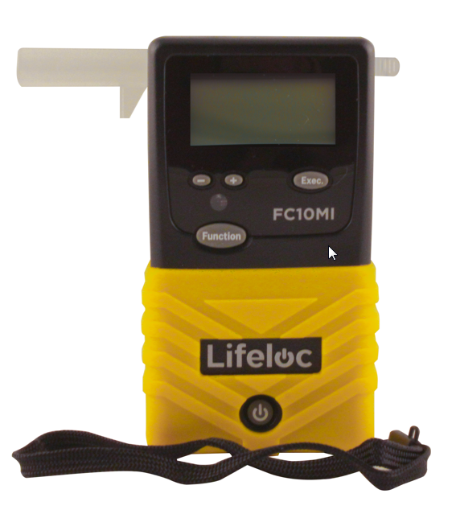

FC10 - Functional Parts

FC10 Interior Components

Fuel Cell
The fuel cell (not visible), which absorbs the alcohol and converts it to electrical current. It is good for approximately 10,000 tests before needing replacement.

Breath Sampling Valve
The breath intake port, which directs the breath sample from the mouthpiece to the fuel cell.

Batteries
The batteries, which power an amplifier and causes the result to be displayed. Four AA alkaline batteries or NiMH batteries are needed to power the device and will last for about 160 “On” hours or up to 6000 tests.

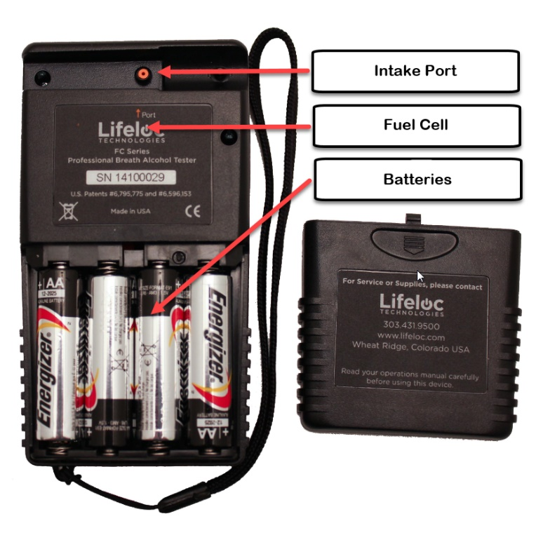

FC10 Exterior Components

Power Button
Press and hold the power button on the bottom of the front of the unit until it beeps. The FC10 preforms an automatic internal diagnostics check.

To turn the unit off, press and hold the power button until it beeps twice. The unit will shut down.

Note: Momentarily pressing the power button, when the unit is on, will return you to the main menu.

Function Button
This button scrolls through the menus and saves changes; as well as clears the display and returns the instrument to the automatic test mode, and if it is pressed three times it will display the results of the last test performed on the instrument. It is also used to calibrate the instrument.

Display Window
The display is numerical to three decimal places, but results should be truncated to two decimal places, and is expressed as grams per 210 liters of breath. (0.12 means 0.12 grams of alcohol per 210 liters of breath). The instrument has a graphic LCD with an automatic back-light feature.

Execute Button
This button is used to manually override an automatic test. It is used with the function button, and well set the instrument to take a manual test. This is the same for the calibration of the instrument.

Minus (-) / Plus (+) Button
These are used during calibration of the instrument.

Wrist Lanyard
This fits around the wrist to ensure the instrument does not slip and fall.

Intake Port
This is where the breath sample enters the fuel cell after the mouthpiece is connected.

Battery Cover
This cover slides down to access the battery compartment.

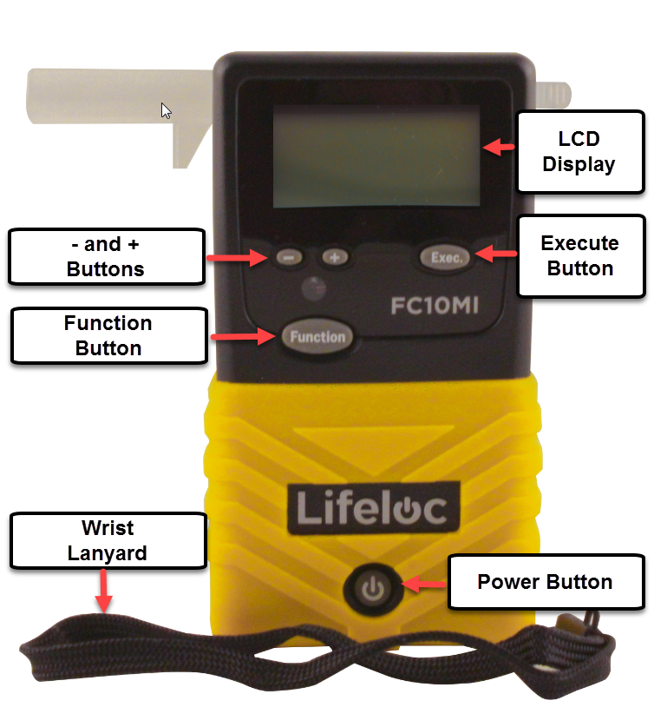

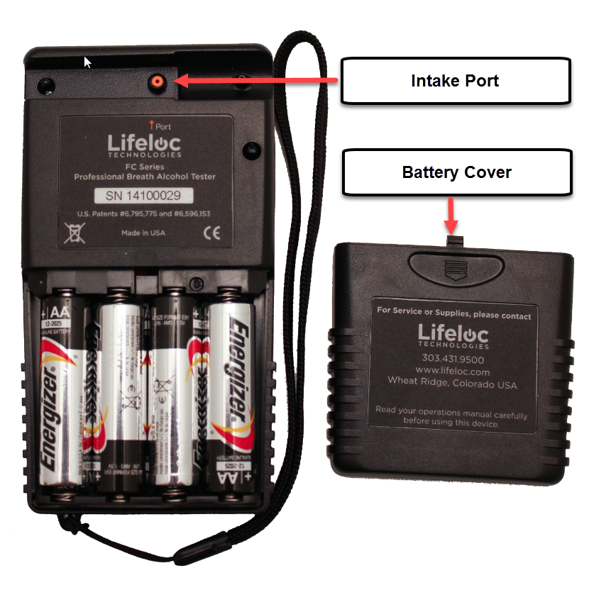

FC10 – Subject Test Sequence

Observation:

Before giving the preliminary breath test, field sobriety tests should be given to the driver, notice he/she should be advised of the PBT notice.

It must be determined that the subject has not smoked, regurgitated or placed anything in his/her mouth for at least 15 minutes prior to the test. Also check to ensure there are no signs of injury or blood in the subject’s mouth. This 15-minute period ensures any residual mouth alcohol that could possibly be left in the subject's mouth if the subject had just finished drinking prior to the test will not affect the results.

Preparation:

Step 1: Attaching a mouthpiece.

- Remove the mouthpiece from its wrapper, making sure not to touch the end the subject will be blowing into.

- Attach the mouthpiece to the port on the back of the FC10. Line the mouthpiece port over the hole in the back of the mouthpiece and press firmly into place making sure it is fit tight.
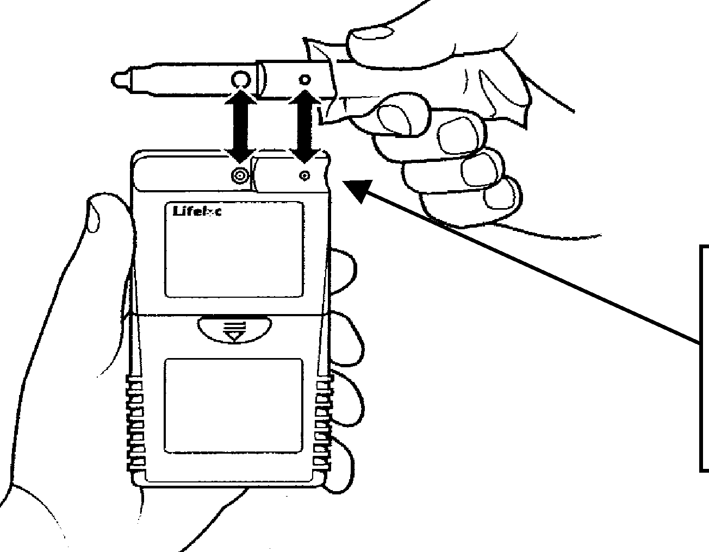

FC10 back view with mouthpiece port

Step 2: Turning the FC10 on.

- Press and hold the POWER button on the unit until a beep is heard. The FC10 will then perform an automatic internal diagnostic check, and if there are no problems it will soon display "AUTO TEST".
- If the instrument is left on for an extended period it will automatically shut off to preserve the life of the batteries.

Automatic Operation

Step 3A: Verify the display reads "AUTO TEST".

Step 4A: Instruct the subject to blow into the mouthpiece for as long and steadily for as they can.

- It is not necessary for them to blow as hard as they can.

- As the subject blows into the mouthpiece the FC10 will show a graph of the breath flow on the display, as well as show the number of liters. Liters are shown in the upper left corner. (See figure A)

- If the FC10 detects alcohol, the alcohol level is graphed and will be displayed before the results are shown. (See figure B)

Figure A Figure B
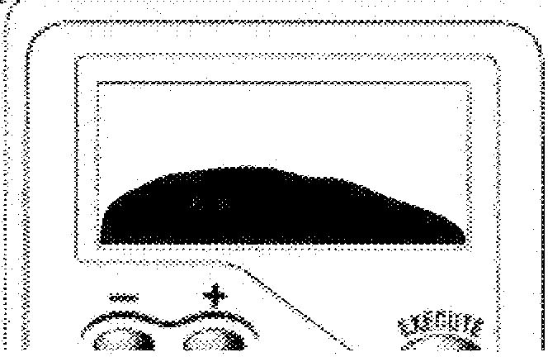
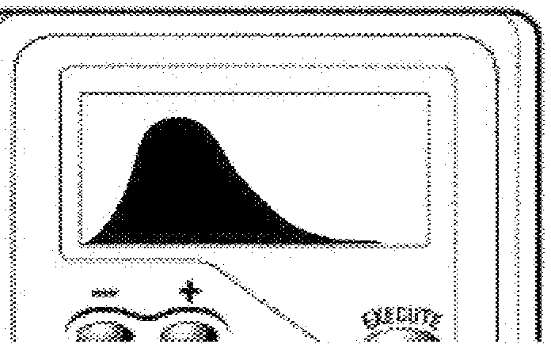

Step 5A: Read the result.

- After taking the test the FC10 will display the results as BrAC to three decimal places.

Step 6A: Remove the mouthpiece.

NOTE: The "AUTO TEST" may be overridden by pressing the "Execute" button while the subject is blowing into the instrument. This allows the completion of a test in the occasional instance when the subject may not be able to activate the automatic test feature.

Automatic operation is the easiest way to achieve a deep lung sample. The FC10 monitors the subject’s breath and automatically takes the sample near the end of the breath flow.

Manual Operation

Step 3B: Verify the display reads "AUTO TEST".

Step 4B: Press the "Function" button until the display reads "MANUAL TEST".

Step 5B: Instruct the subject to blow into the mouthpiece for as long and steady as they can.

- They do not necessarily have to blow as hard as they can.

Step 6B: When the subject is near the end of their breath, press the "Execute"
button.

- After the "Execute" button is pressed, the FC10 will show a graph of the breath flow on the display. (See figure 5b)

- If the FC10 detects alcohol, the alcohol level is graphed and will be displayed before the results are shown. (See figure 5c)

Step 7B: Read the result displayed.

Passive Operation

Step 3C: Verify the display reads "AUTO TEST".

Step 4C: Press the "Function" button until the display reads "PASSIVE TEST".

Step 5C: Hold the FC10 sample port, (orange colored opening labeled "Port" on the back of the FC10), about 4 inches from the subjects’ mouth.

- Have the subject blow towards the port.

Step 6C: When the subject is still blowing, press the "Execute" button.

- After the "Execute" button is pressed, the FC10 will only show a "POS" or "NEG" on the display.

- A passive test can be done over an open container to detect the presence of alcohol.

FC10 Error Messages

<1.3L Retest or Try Manual Test Breath flow ended before the subject blew 1.3 liters of breath. Instruct subject to try again or use manual test mode.

>0.4 BrAC is unusually high and above 0.40 BrAC.
Subject may require medical attention.

External Interference External Interference, has been detected. Move to a different location and try again. If error persist call Lifeloc Technical Support.

Flow Error Retry & Blow Steady Exhalation not complete or interrupted. Instruct the subject to blow steadily as long as they can.

Invalid Calibration/Cal Check No alcohol was detected. Repeat setup, then retest.

Log Empty There are no results in the memory.

Low Battery Battery voltage is too low to take a test. Replace batteries

Pump Reset Needed The pump needs to be reset. Follow onscreen instructions.

Temperature When calibrating or taking a test, unit is outside of temperature limits.
Calibration range = 68℉ – 95℉ (20℃-35℃)
Testing range = 32℉-130℉ (0℃-55℃)

Timeout User blew for > 15 seconds. Please try again, blow harder.

Additional PBT Operational Tips

Some additional tips to remember when using the PBTs.

- The fuel cell must be clean prior to the test. The FC10 will display "AUTO TEST" when ready.

- Avoid extreme temperature ranges. In cold weather keep the PBT in your pocket during the stop until just prior to use. If outside the proper temperature range, the FC10 will display "TEMPERATURE" and will not perform a subject test.

- A deep lung sample is important for best results.

- Radio interference may affect the PBT, therefore do not operate the vehicle radio, a base radio, or a portable radio while taking the sample. The FC10 will display "EXTERNAL INTERFERENCE” and will not perform a subject test.

- Do not allow subject to blow raw cigarette smoke into the unit as it shortens the life of the fuel cell. Discretion should be used when in a smoke-filled area for the same reason.

Remember the PBT is not a substitute for proper investigative techniques. Field sobriety tests should still be conducted. They provide valuable evidence for prosecution, especially if the evidential breath test has been refused or suppressed in court.

Administrative Rules

DEPARTMENT OF STATE POLICE

TRAINING DIVISION

TEST FOR BREATH ALCOHOL

Filed with the Secretary of State on January 16, 2018.

These rules take effect immediately upon filing with the Secretary of State unless adopted under sections 33, 44, or 45a(6) of 1969 PA 306. Rules adopted under these sections become effective 7 days after filing with the Secretary of State.

(By authority conferred on the department of state police by section 190 of 1945 PA 327, MCL 259.190, and section 625a of 1949 PA 300, MCL 257.625a)

R 325.2651, R 325.2652, R 325.2653, R 325.2654, R 325.2655 are amended and
R 325.2656, R 325.2657 are rescinded to the Michigan Administrative Code as follows:

R 325.2651 Definitions.
Rule1. (1) As used in these rules:
(a) "Acts" means 1945 PA 327, MCL 259.190, 1949 PA 300, MCL 257.625a, 1993 PA
354, MCL 462.359, 1994 PA 451, MCL 324.80181, MCL 324.81136, and MCL
324.82137.
- "Alcohol standard" means a certified alcohol standard.
- "Calendar month" means 12:01 a.m. on the first date of any of the 12 named months of the year to midnight on the last date of the same month.
- "Calendar week" means 12:01 a.m. Sunday to midnight Saturday.
- "Class" means a classification of operator status as certified by the department, based on training and function as specified in R 325.2658.
- "Department" means the department of state police.
- "Equipment" means evidential and preliminary breath alcohol test instruments, simulator devices, calibration stations, forms, and any accessories and supplies necessary for compliance with the procedures in these rules or law.
- "Evidential breath alcohol analysis" means chemical analysis of an essentially alveolar breath sample that indicates a specific result in grams of alcohol per 210 liters of breath.
- "Evidential breath alcohol test instrument" means an evidential breath testing device that indicates a specific result in grams of alcohol per 210 liters of breath.
- "Preliminary breath alcohol analysis" means chemical analysis of essentially alveolar breath samples that indicates the presence or absence of alcohol in a person's blood.
- "Preliminary breath alcohol test instrument" means a breath alcohol screening device that indicates the presence or absence of alcohol in a person's blood.
- "Shall" means that a function is mandatory.
- "Should" means that a function is recommended, but not mandatory, with reasonable deviation allowed.
(2) Terms used in the acts have the same meanings when used in these rules.

R 325.2652 Approved equipment.
Rule2. (1) Evidential and preliminary breath alcohol test instruments shall be tested by and shall meet the existing model specifications for evidential breath alcohol analysis as established by, the United States Department of Transportation, National Highway Traffic Safety Administration. The specifications, identified as "Model Specifications for Evidential Breath Testing Devices," 49 FR 48855 et seq., (December 14, 1984), as amended by 58 FR 48705 et seq., (September 17, 1993), 62 FR 43416 et seq., (August 13, 1997), 69 FR 42237 et seq., (July 14, 2004), 71 FR 37159 et seq., (June 29, 2006), 72 FR 71480 et seq., (December 17, 2007) and FR Doc. 2012-14582 (June 14, 2012) are adopted in these rules by reference. A copy of the specifications and a current conforming products list are available from the U.S. Department of Transportation, National Highway Traffic Safety Administration, 1200 New Jersey Avenue SE, Washington, D.C. 20590, or from the Michigan State Police, Training Division, 7150 Harris Drive, P.O. Box 30634, Lansing, MI, 48909.
- If the United States Department of Transportation discontinues the testing of evidential breath alcohol test instruments or the issuance of model specifications for such testing, only those instruments tested and approved by the department shall be used.
- An application for equipment approval shall be submitted to the department.
- Only equipment approved by the department for evidential and preliminary breath alcohol analysis shall be utilized by operators.

R 325.2653 Equipment accuracy.
Rule 3. (1) An appropriate class operator who has been certified in accordance with R 325.2658 shall verify an evidential breath alcohol test instrument for accuracy at least once each calendar week, or more frequently as the department may require. Alternatively, a pre-programmed self-test for accuracy may be initiated by the evidential breath alcohol test instrument and recorded by an appropriate class operator who has been certified in accordance with R 325.2658 if the instrument is so equipped and programmed. The tests for accuracy are not required to be performed within 7 days of each other. The test for accuracy shall be made using an alcohol standard that is approved by the department. For the evidential breath alcohol test instrument to meet the requirements for accuracy, a test result not exceeding +/- 5% shall be obtained when using a controlled device. Controlled devices include both of the following:
  - Wet bath device that delivers an alcohol vapor concentration test result of .080 grams of alcohol per 210 liters of vapor.
  - Compressed alcohol gas device that delivers a test result of .080 grams of alcohol per 210 liters of vapor after applying applicable altitude or topographic elevation correction factor supplied by the manufacturer. The correction factor may be applied by the operator or by the evidential breath alcohol test instrument if so pre-programmed.
- An appropriate class operator who has been certified in accordance with R 325.2658 shall verify for accuracy a preliminary breath alcohol test instrument at least monthly, or more frequently as the department may require. The test for accuracy shall be made using an alcohol standard that is approved by the department. For the preliminary breath alcohol test instrument to meet the requirements for accuracy, a test result not exceeding

+/- 5% shall be obtained when using a controlled device. Controlled devices include both of the following:
  - Wet bath device that delivers an alcohol vapor concentration of .080 grams of alcohol per 210 liters of vapor.
  - Compressed alcohol gas device that delivers a test result of .080 grams of alcohol per 210 liters of vapor after applying applicable altitude or topographic elevation correction factor supplied by the manufacturer. The correction factor may be applied by the operator or by the preliminary breath alcohol test instrument calibration station if so pre- programmed.
- Approved evidential breath alcohol test instruments shall be inspected, verified for accuracy, and certified as to their proper working order within 120 days of the previous inspection by either an appropriate class operator who has been certified in accordance with R 325.2658 or a manufacturer-trained representative approved by the department.

R 325.2654 Equipment repair and service.
Rule 4. (l) The repair and service of equipment approved by the department for evidential and preliminary breath alcohol analysis shall be at the expense of the agency using the equipment. The department or the agency using the equipment may arrange to have this service provided either by an appropriate class operator who has been certified in accordance with R 325.2658 or a manufacturer-trained authorized representative approved by the department.
- After repair or service and before being placed in service, evidential and preliminary breath alcohol test instruments shall be verified for accuracy in accordance with the provisions of R 325.2653 and records of verification shall be kept as required by the department.

R 325.2655 Techniques and procedures.
Rule 5. (1) A procedure that is used in conjunction with evidential breath alcohol analysis shall be approved by the department and shall be in compliance with all the following provisions:
  - Except as provided otherwise in these rules, evidential breath alcohol test instruments shall only be operated by appropriate class operators who have been certified in accordance with R 325.2658.
  - All analyses shall be conducted following procedures approved by the department and using forms approved by the department as required.
  - Records of operation, analyses, and results shall be maintained at the evidential breath alcohol test instrument location as prescribed by the department, and copies forwarded to the department as required.
  - The department shall test samples from each lot of alcohol standards used in the state in conjunction with evidential breath alcohol test instruments. The department shall certify for use those lots of alcohol standards that are found to be proper in chemical composition.
  - A person may be administered an evidential breath alcohol analysis on an evidential breath alcohol test instrument only after being observed for 15 minutes before collection of the breath sample by at least 1 appropriate class operators who is certified in accordance with R 325.2658. The observation period may be conducted by more than 1 operator working in concert. During the observation period, the person shall not have smoked, regurgitated, or placed anything in his or her mouth, except for the mouthpiece associated with the performance of the evidential breath alcohol analysis. The operator need not stare continuously at the person but must be close enough to be aware of the person's actions and conditions. The operator may complete paperwork, enter data into the evidential breath alcohol test instrument, or conduct other reasonable tasks during the observation period provided the person is within the operator's field of vision. Breaks in the observation period lasting only a few seconds do not invalidate the observation provided the operator can reasonably determine that the person did not smoke, regurgitate, or place anything in his or her mouth during the breaks in the observation.
  - The operator shall request a second evidential breath alcohol from the person being tested and administered, unless the person refuses to give the second breath sample, or a substance is found in the person's mouth subsequent to the first evidential breath alcohol analysis that could interfere with the breath sample result. Obtaining the first breath sample result is sufficient to meet the requirements for evidentiary purposes prescribed in section 625c of 1949 PA 300, MCL 257.625c. The purpose of obtaining a second breath sample result is to confirm the result of the first breath sample result. A second breath sample result shall not vary from the first breath sample result by more than the allowable variation listed in Table 1.

Table 1
Breath alcohol allowable variation of second breath sample result range from the first breath sample result
0.00 - 0.14 +/- 0.01
0.15 - 0.24 +/- 0.02
0.25 - 0.34 +/- 0.03
0.35 - or more +/- 0.04

If the variation is more than that allowed in Table 1, the operator shall request a third breath sample from the person being tested and a third breath sample result may be obtained. If the third breath sample result does not conform to the allowable variation in Table 1 of either of the first 2 tests, the person shall be requested to submit a blood or urine sample for analysis in accordance with MCL 257.625a and the procedures established in R 325.2671 to R 325.2677.
  - The results of an evidential breath alcohol analysis of a person's breath shall be expressed in terms of grams of alcohol per 210 liters of breath, truncated to the second decimal place. For example, 0.237 found shall be reported as 0.23.
- A procedure that is used in conjunction with preliminary breath alcohol analysis must be approved by the department and shall be in compliance with all the following provisions:
- Except as provided otherwise in these rules, preliminary breath alcohol test instruments shall only be operated by appropriate class operators who have been certified in accordance with R 325.2658
- A person may be administered a preliminary breath alcohol analysis on a preliminary breath alcohol test instrument only after the operator determines that the person has not smoked, regurgitated, or placed anything in his or her mouth for at least 15 minutes.
- Records shall be maintained at the preliminary breath alcohol test instrument location as prescribed by the department and copies shall be forwarded to the department as required.
- A person's welfare shall be protected by requesting medical assistance if the result of the evidential or preliminary breath alcohol analysis is 0.35 or more. Failure to request medical assistance does not affect the validity or evidential value of the result of an evidential or preliminary breath alcohol analysis.

R 325.2656 Rescinded.

R 325.2657 Rescinded.

R 325.2658 Operator training and certification.
Rule 8. (1) The department shall train and certify personnel of law enforcement agencies to perform various functions as described in this rule, and shall designate such persons as class I, class II, class IIIA, class IIIB, class IVA, or class IVB operators. An operator may hold multiple and concurrent classifications. Operator certification is non-expiring.
- The minimum training requirements and proficiency standards for operator certification are as follows:
    - A class I operator shall complete a class I training course approved by the department, obtain a minimum score of 70% on a written examination administered by the department, and demonstrate proficiency in the operation of a preliminary breath alcohol test instrument to the department. The department shall provide a person who fails to pass the written examination or demonstrate the required proficiency a second opportunity to take the written examination or demonstrate the required proficiency. A person who fails on his or her second opportunity to successfully pass the written examination or demonstrate the required proficiency must retake the class I training course, successfully pass the written examination, and demonstrate the required proficiency, to qualify for class I operator certification.
    - A class II operator shall complete a class II training course approved by the department, obtain a minimum score of 70% on a written examination administered by the department, and demonstrate proficiency in the operation of an evidentiary breath alcohol test instrument to the department. The department shall provide a person who fails to pass the written examination or demonstrate the required proficiency a second opportunity to take the written examination or demonstrate the required proficiency. A person who fails on his or her second opportunity to successfully pass the written examination or demonstrate the required proficiency must retake the class II training course, successfully pass the written examination, and demonstrate the required proficiency, to qualify for class II operator certification.
    - A class IIIA operator shall be currently certified as a class I operator, complete a class IIIA training course approved by the department, obtain a minimum score of 70% on a written examination administered by the department, and demonstrate proficiency in the verification and calibration of a preliminary breath alcohol test instruments to the department. The department shall provide a person who fails to pass the written examination or demonstrate the required proficiency a second opportunity to take the written examination or demonstrate the required proficiency. A person who fails on his or her second opportunity to successfully pass the written examination or demonstrate the required proficiency shall be required to retake the class IIIA training course, successfully pass the written examination, and demonstrate the required proficiency to qualify for class IIIIA operator certification.
    - A class IIIB operator shall be currently certified as a class II operator, complete a class IIIB training course approved by the department, obtain a minimum score of 70% on a written examination administered by the department, and demonstrate proficiency in the limited service of an evidentiary breath alcohol test instruments to the department. The department shall provide a person who fails to pass the written examination or demonstrate the required proficiency a second opportunity to take the written examination or demonstrate the required proficiency. A person who fails on his or her second opportunity to successfully pass the written examination or demonstrate the required proficiency shall be required to retake the class IIIB training course, successfully pass the written examination, and demonstrate the required proficiency to qualify for class IIIB operator certification.
    - A class IVA operator shall be currently certified as a class III operator, complete a class IVA training course approved by the department, and demonstrate proficiency instructing class II and class IIIA operator training courses approved by the department. The department shall provide a person who fails to demonstrate the required proficiency a second opportunity to demonstrate the required proficiency. A person who fails on his or her second opportunity to demonstrate the required proficiency shall be required to retake the class IVA training course and demonstrate the required proficiency to qualify for class IVA operator certification.
    - A class IVB operator shall be currently certified as a class IVA operator that has been designated by the department to administer the breath alcohol testing program for the state of Michigan. Before class IVB designation, the class IVB operator shall receive additional training in the repair and service of evidential and preliminary breath alcohol test instruments by the manufacturer of such instruments.
- The department shall develop and distribute to each certified operator a training manual for each of the operator's classification. Training manuals must specify the functions performed by each class pursuant to this rule, as well as the knowledge and skills necessary to perform the appropriate functions.
- The primary functions of each class are described in Table 2. Additional functions not described in Table 2 may be designated by the department and described and explained in the appropriate training manual.
- A person who meets the training requirements and proficiency standards for operator certification in accordance with this rule shall be issued a certification card for the appropriate class by the department. The certification card shall remain the property of the department.
- A class I, class I, class IIIA, class IIIB, class IVA, and class IVB operator shall comply with all applicable department rules, policies, and procedures or the department may suspend his or her operator certification. A person whose operator certification has been suspended by the department shall return his or her certification card to the department within 7 days of receiving notice of the suspension. A person shall make a request for reinstatement of operator certification to the department in writing and, upon approval, the department may require the person to complete an operator training, pass a written examination, and/or demonstrate required proficiency.

Table 2

OPERATOR FUNCTION OPERATOR CLASS
 | I | II | IIIA | IIIB | IVA | IVB
Train and certify class I operators |  |  | X |  | X | X
Train and certify class II operators |  |  |  |  | X | X
Train and certify class IIIA operators |  |  |  |  | X | X
Train and certify class IIIB operators |  |  |  |  |  | X
Train and certify class IVA operators |  |  |  |  |  | X
Administer preliminary breath alcohol analyses using preliminary breath alcohol test instruments approved for use by the department | X | X | X |  | X | X
Administer evidentiary breath alcohol analyses using evidential breath alcohol test instruments approved for use by the department |  | X |  | X | X | X
Verify for accuracy and calibrate preliminary breath alcohol test instruments approved for use by the department |  |  | X |  | X | X
Verify for accuracy evidential breath alcohol test instruments approved for use by the department |  | X |  | X | X | X
Inspect, certify, service, repair, and calibrate evidentiary breath alcohol test instruments approved for use by the department for proper working order |  |  |  |  |  | X
Provide service on preliminary breath alcohol test instruments approved for use by the department |  |  |  |  |  | X
Conduct inspections for compliance with applicable department rules, policies, and procedures |  |  |  |  |  | X
Provide limited service on evidentiary breath alcohol test instruments specified by the department |  |  |  | X

